**24-677 Modern Control Theory  
Project 1**

**Exercise 1:**

1. **Linearized State Equations for Arbitrary Point**

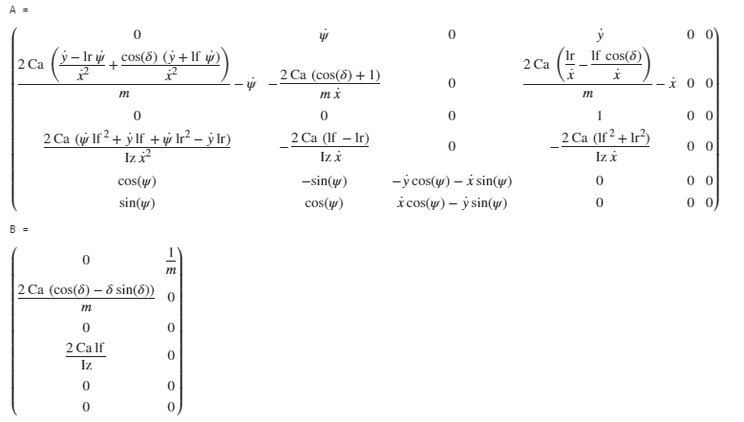

**With Terms and Values Substituted In**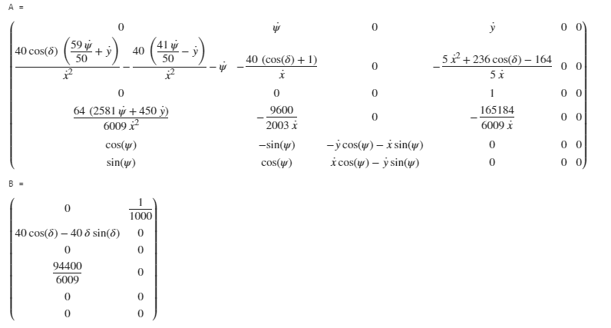

**MATLAB Code** 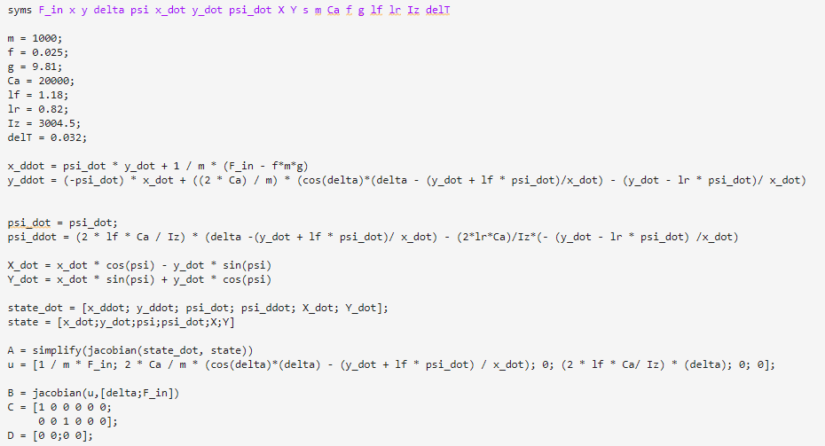

1. **Linearized Model about Operating Point**

**Operating Point Calculation and Updated Matrixes**

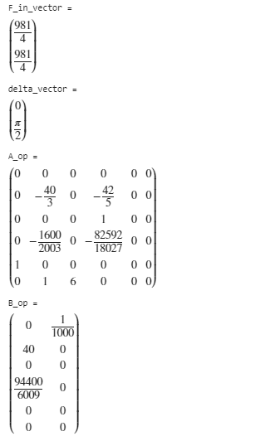

**MATLAB Code**

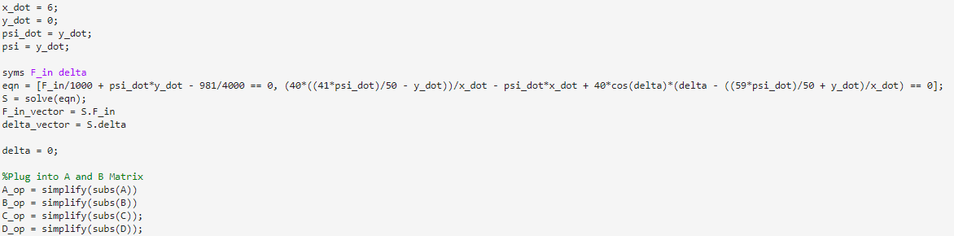

1. **Transfer Functions**

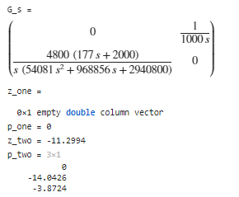

**MATLAB Code**

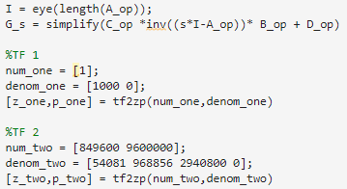

**TF 1: Zeros: N/A Poles: s = 0**

**TF 2: Zeros: -11.04 Poles: s = 0, -14.04, -3.87**

**Exercise 2:**

**Program Graphs**

